Talybont-on-Usk Community Council Annual Report 2022/2023

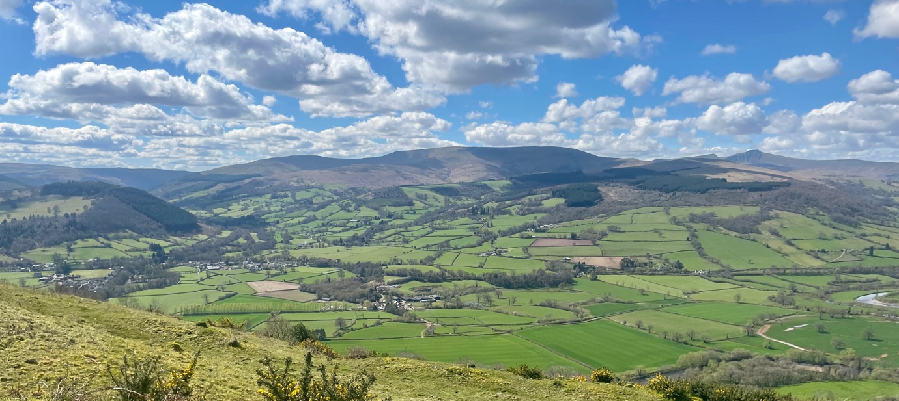

1. Foreword Pg 1
2. Roles and Functions of the Council Pg 1
3. Membership of the Council Pg 1
4. The Council’s Work in 2022-2023 Pg 2-3
5. Future Priorities Pg 3-4
6. Attending the Council / Contact us Pg 4

1. Foreword
We are pleased to present the annual report of Talybont on Usk Community Council. It provides an overview of its work of the Council during the period 1st May 2022 to 30th April 2023.
2. Roles and Functions of Talybont on Usk Community Council
The 1972 Local Government Act states that every part of Wales is in a community. In England, the term “Parish Councils” is still used. In Wales, however, the legal and constitutional term for these units of local government administration is termed “Community Councils”.
The Community Council represents the lowest tier of local government and is closest to the public as regards meeting local needs. The Council has several statutory rights and duties. What is the Council structure? A list of your local councillors is provided on the next page.
The Community Council has 9 Councillors who do not represent any political party. They are elected every 5 years. A part time Clerk is employed to handle all arrangements for meetings and preparing an agenda to deal with the records and financial and administrative matters linked to implementing the Council’s work. Contractors are also employed to carry out specialist work such as repair and maintenance i.e., grass cutting and so on.
The Community Council makes observations on planning applications before they are decided upon by Bannau Brycheiniog National Park. They provide funding for events, clubs, and services in the community.
How does the Council work? Any work done by the Council will be implemented following decisions taken at open meetings. Any work is paid for with public money which the Council receives through raising a precept which is part of the Council Tax set by Powys County Council. The precept is raised to finance the Community Council’s responsibilities including grass cutting and defibrillator maintenance and contributions to local organisations.
Can the public attend the meetings? By all means. You are welcome to attend our meetings. Members of the public are permitted to speak for up to 3 minutes with advance notification to the clerk.
Council meetings are held monthly, except for August and December, and are usually held on the third Monday of each month at Henderson Hall. The Annual Meeting is a legal obligation as stated by the Local Government Act 1972. The annual meeting must be held in the month of May. Council decides on the date. The first item on the agenda must be the election of the Chairman of the Community Council for the next twelve months.
Talybont on Usk Community Council has 9 Councillors

3.Membership of the Council
Councillor Geraint James Elected 05/05/2022
Councillor Colin Parry Elected 05/05/2022
Councillor Ellen Moorman Elected 05/05/2022
At the time of this report there are 6 vacancies on the Community Council

4. The Council’s Work in 2022-2023
Annual Audit
Passed with no issues. Clear audit achieved.
Gilestone Farm
Last May the Welsh Government (WG) announced the purchase of Gilestone Farm with a view to lease the farm to the Greenman group. This caused large concern to the community of Talybont around conservation, noise, traffic, and mass tourism events, in a village that is already a tourism hot spot.
A working group was formed to create a survey for the community. It was decided to wait for release when facts were available to include, preventing more upset and fear from arising.
The Council had an informal meeting with Fiona Stewart (director of the GMF/T) in May of 22 and waited for a follow-up meeting with her and the Welsh Government. A meeting with the WG occurred in November and a meeting with key stakeholders, Fiona Stewart and the WG in March. We have been awaiting details from the WG about the ‘business plan’.
The Council has submitted detailed questions about the plans for the site with little information received to date. Pressure continues from the Usk Valley Conservation Group, who released their own poll in December) as well as community members to take a stance against the plans. There are also constituents who are supportive. TOUCC have chosen to follow the regulatory advice, and to wait for more detail on events and plans before making considered decisions.
Talybont Activity Centre (Old Railway Station)
Following the Bannau Brycheiniog National Park decision to grant a Certificate of Lawfulness for the development of the Activity Centre. The council argued its validity after numerous residents confirmed that the site had never previously been a campsite. The argument and the following appeal were both rejected. Karl Speed presented his plan to the council in February 23.
One Voice Wales
Talybont-on-Usk continues their membership in One Voice Wales. They are represented on the NEC and the Policy Committee of the NEC. They are also participating in the audit board.
Installation of speed warning signs
Four sites were equipped with poles and sockets for installing two speed information signs. Two sites are in Talybont and two sites in Pencelli. They have proven effective
Henry Vaughan Garden
Members of the Council fixed unstable handrails and fencing in the garden.
Playground Improvements
The village playground has had a new fence to replace the damaged old fence and ensure child safety. More trees were planted on the north end.

MUGA Repairs
Following the flood damage, the MUGA has been repaired. The floodlights have been set for appropriate hours of lighting.
Council Website
The council redesigned their website to include statutory requirements set by the WG.
Council Facebook Page
The Council set up a facebook page to keep the community informed
Resignations
Several Councillor resignations have occurred in the last 12 months. In addition to this the Clerk also resigned. Although numerous reasons were given for resignations, Gilestone Farm was a common denominator. The Council wishes to thank all people involved for their service over the years.

5. Future Priorities
- Make sure the Council is fully compliant with all statutory requirements in The Local Government and Elections (Wales) Act 2021: Statutory Guidance for Community and Town Councils
- Training: The council will ensure all of the members are fully trained in the Code of Conduct and basic functions of Community Councils as well as encouraging training in other courses that wil be beneficial.
- Instigate a council communication protocol to make sure that every matter is addressed as promptly and effeciently as possible and that the entire council is informed.
- Instigate a Communication Strategy with the Welsh Government for the land they have purchased.
- Schedule a Community Assembly and subsequent Survey to ascertain where the community stands on a variety of issues.
- Implement the Finance and Governance Toolkit
- Biodiversity Plan: work with members of the community to ensure that we are caring for the wide array of flora and fauna our stretch of land hosts and protecting them for future generations in our day to day activities
- Place Plan: The council will commence working with the National Park Authority to develop a place plan. We will be looking at issues such:
- how the community be able to accommodate the rising level of tourism and both the benefits and probleman s that arise from it,
- the cost of living crisis
- infrastructure
- an aging community
- climate change and the effects it may have
- Ensure the Wellbeing for Future Generations Act is considered in all council activities
- Follow up with the Canal and River Trust to ensure our stretch of the canal is not dangerous.
- Follow up with Powys roads to introduce the 20Mph Speed limit and make certain the roads are in safe driving condition and marked appropriately throughout our villages.

6. Attending the Council / Contact us
Attending meetings of Talybont on Usk Community Council
The Council is keen to see Members of the public attend Talybont on Usk Community Council meetings. You may attend in person or via Zoom. Except for confidential items, all business is held in public. All the public agenda papers are published online 3 working days in advance of the meeting and draft minutes are published within 7 days.
Contact us.
Email talybontcc@gmail.com
Website https://www.talybont.org/
Members contact details https://www.talybont.org/your-council.html

